KFCCALMT9709 - EXAM PAPER - 200506 - MATHS P6 - SEMESTER 01 - TAYLOR (ANS)

- 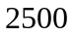
- 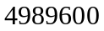 , 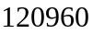
- 0.61 , 0.54

 | 2 | 3 | 4 | 5 | 6
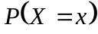 | 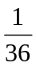 | 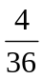 | 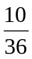 | 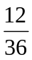 | 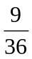

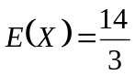 , 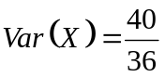

- 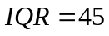 , 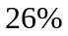
- 176.38 , 166.723
-   